srshrss 2.9 (uJy)above. Red dot Smin in each band. FAST in each band; Bule dotsantain ample opptunities for independent learnin MSPs Simulation by Using the Wide-bandwidth receiver of the FAST

**1 Results**

This is a simulation for MSPs, which can be detected by using the Wide-bandwidth receiver of the FAST. In this simulation, we got:

GalSample_MSP.db: is the population of MSPs in the Milk Way.

Based on GalSample_MSP.db, we used the Wide-bandwidth receiver of the FAST to detect MSPs. Here we divided the Wide-bandwidth receiver into two parts (see Zhang et al. 2016 ).

FASTBand1_MSP.db: is the result of Band1

FASTBand2_MSP.db: is the result of Band2

The data file for each column means (see Bates et al. 2014):

C1: Period (ms),

C2: DM (cm^-3 pc),

C3: X (kpc),

C4: Y (kpc),

C5: Z (kpc),

C6: Width (degrees),

C7: alpha (deg),

C8: rho (deg),

C9: Spectral Index,

C10: S1400 (mJy),

C11: Galactic Longitude (degrees),

C12: Galactic Latitude (degrees),

C13: Distance (kpc),

C14: GalacticRadius (kpc)

**2 Processing Steps**

**Step1:** Generate MSPs’ Population Model

> python populate.py -n 26 -surveys PKSMB -rdist lfl06 -zdist exp -z 0.5 -pdist cc97 -ldist lnorm -si -1.4 0.96 -dm ne2001 -o GalSample_MSP.model

**Result:** GalSample_MSP.model (32049)

**Note:** Table1 gives the difference between Smit09 and ZL15.

**Step2:** Simulate FAST Pulsar Survey

> python dosurvey.py -f GalSample_MSP.model -surveys FASTBand1 FASTBand2

**Results:**

FASTBand1_MSP.results (543), FASTBand2_MSP.results (495)

**Note:** Table2 gives the parameters of each survey model.

Output data in outputdata_zl

>python python outputdata.py # has one “.model” or “.result” each time

can get name_ori.db

> cat GalSample_MSP_ori.db | sed -e '/^$/d' > GalSample_MSP.db # remove blank line

can get name_.db

**Step3:** Calculate the Smin of FAST in each band

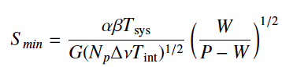

where P=10ms, DM=100cm-3pc.

**Results:** Using this equation, the results as below

Smin_Band1: 32.9 (uJy), , Smin_Band2: 33.6 (uJy)

**Step4:** Sift out the pulsars above the threshold (Smin)



Band1: flux > 32.876997912 (uJy) Band2: flux > 33.5668347995 (uJy)

**Results:** the number of simulated psrs’ S1400 above the Smin in each band. Here the Smin has scaled to S1400.

Band1: 526

Band2: 489

**Notes:** Fig3/4 show the results above. Red circles are the MSPs that can be detected by FAST in Band1/2; Blue dots are the MSPs above the Smin in Band1/2.

Table 1

|  |  |  |
| --- | --- | --- |
|  | Smits09 | Zhang16 |
| Software  name  No  -n  -surveys  -rdist  -zdist  -z  -pdist  -ldist  -si  -dm  -o  MSP  -n  -surveys  -rdist  -zdist  -z  -pdist  -ldist  -si  -dm  -o  Results  _Nor.model Number  _MSP.model Number | PsrPop  1005  PKSMB, PKSHL  lfl06  exp  0.33  lnorm  lnorm  -1.6 0.35  ne2001  GalSample_Smits_Nor.model  49  PKSMB, PKSHL,PKS70,  PKSSW1, PKSSW2  lfl06  exp  0.5  Lorimer09 (=lnorm?)  lnorm  -1.6 0.35  ne2001  GalSample_Smits_MSP.model  120,000  23,000 | PsrPopPy  1364  PKSMB,PKSHL,  PKSSW1, PKSSW2  lfl06  exp  0.33  lnorm  lnorm  -1.4 0.96  ne2001  GalSample_ZL_Nor.model  26  PKSMB  lfl06  exp  0.5  cc97  lnorm  -1.4 0.96  ne2001  GalSample_ZL_MSP.model  140,000  24,000 |
|  |  |  |

Table1 Notes

PKSMB: Parkes Multibeam Pulsar Surveys at the Galactic plane (Manchester et al. 2001)

PKSHL: Parkes Multibeam Pulsar Surveys at high latitudes (Burgay et al. 2006).

PKS70: Parkes 70-cm pulsar survey of the southern sky (Manchester et al. 1996)

PKSSW1: Parkes-Swinburne multibeam survey at intermediate latitude. (Edwards et al. 2001)

PKSSW2: Parkes-Swinburne multibeam survey at high latitude. (Jacoby et al.2007)

Table 2

|  |  |  |
| --- | --- | --- |
| Survey  Name | FAST  Band1 | FAST  Band2 |
| integration time (s)  centre fre (MHz)  bandwidth (MHz)  degradation factor  antenna gain (K/Jy)  sampling time (ms)  Tsys (K)  channel width (MHz)  polarizations  full-width half max  min RA (deg)  max RA (deg)  min DEC (deg)  max DEC (deg)  min gl (deg)  max gl (deg)  min abs(gb) (deg)  max abs(gb) (deg)  sky coverage  min S/N  Smin (uJy) | 33  560  580  1.0  16.  0.05  35.  0.111  2  2  0  360  -14  66  -180  180  0  90  1  8.0  32.8 | 14  1295.  325  1.0  16.  0.05  35.  0.111  2  2  0  360  -14  66  -180  180  0  90  1  8.0  33.6 |

Table2 Notes

Fig1 gives the parameters for the Wide-bandwidth system of FAST

Fig2 gives the bands of Wide-bandwidth system and the results of drift time at different frequencies.

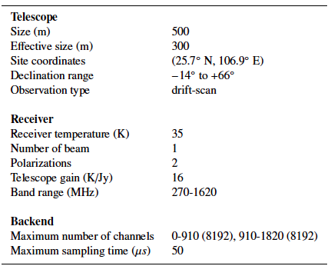

Fig1: The Wide-bandwidth system of FAST

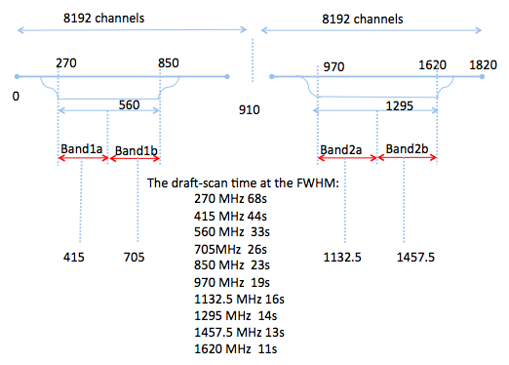

Fig2: Likely Bands for Wide-bandwidth system.

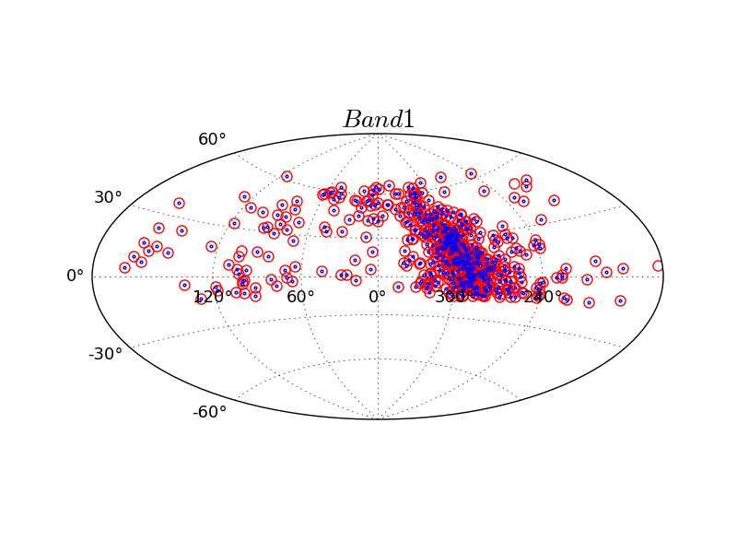

Fig3: Red circles (543) are the MSPs that can be detected by FAST in band1; Blue dots (526) are the MSPs above the Smin in band1.

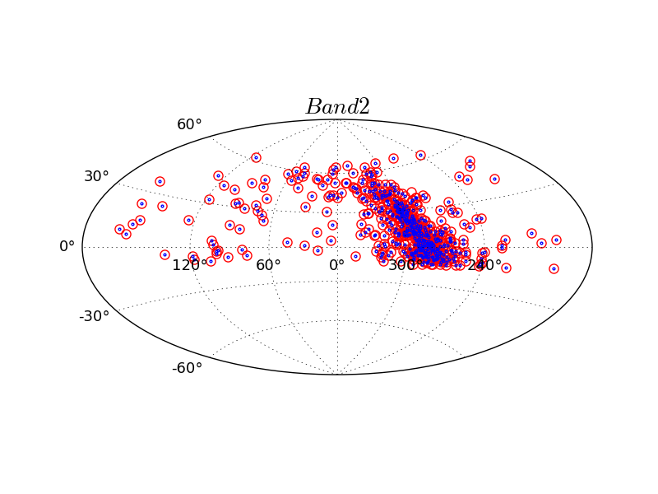

Fig4: Red circles (495) are the MSPs that can be detected by FAST in band2; Blue dots (489) are the MSPs above the Smin in band2.